

Research Funding Proposal Form

Date of Initial Request:07-04-2026
Date of Approval by Chairperson – Research:
Date of Approval by Principal, Great Lakes, Gurgaon:

Milestone-based disbursal: Yes/No – No

1. General Information
Title of the Research Proposal: Synthetic Qualitative Data in Information Systems Research:
Principal Investigator (PI): Dr. Harish Kumar
Department: Marketing
Institution: Great Lakes Institute of Management, Gurgaon
Email: Harish.k@greatlakes.edu.in
Phone: 8398034573
Co-Investigators (if any): Professor Neha Kumari
Institution affiliation of co-investigators: – IIT Jodhpur

2. Project Overview
Abstract (100-150 words): This project develops and validates the Synthetic Qualitative Data Appropriateness (SQDA) framework to address a core limitation in IS research: restricted access to critical stakeholders (e.g., technology managers, platform workers, domain experts).
The study combines human-subject data with LLM-generated synthetic data to rigorously evaluate when synthetic qualitative evidence can be used in top-tier IS research.

Research Objectives (bullet points): -
• Develop a decision framework for synthetic qualitative data use
• Compare human vs. synthetic qualitative data
• Identify boundary conditions of validity
• Contribute methodological standards to IS research
Significance of the Research:
The project provides empirical evidence on how consumers psychologically respond to AI-generated content, which is critical in shaping ISR, Findings will support theory-building and inform business practice, especially in high-engagement sectors where AI is rapidly evolving.

Research Methodology (brief):
A series of four experiments will be conducted using Prolific for participant recruitment. Each study will manipulate AI-driven content variables and measure consumer responses through validated scales. Tools like Qualtrics and AI generation platforms (e.g., GPT, image synthesis) will be employed. Data analysis will use ANOVA, regression, and mediation models.

Timeline and Milestones:
- Data collection (Prolific): May–June 2026
- Analysis and validation: July 2026
- Manuscript preparation: August 2026
- Submission: September 2026

Expected Outcomes/deliverables: -
A*/FT 50 Category – Information System Research

3. Budget and Justification

Total Budget Requested: ₹64,000
Budget Breakdown:
Personnel Costs: -NONE
Materials and Supplies: -NONE
Travel: -NONE
Data Collection: 58000 INR via Prolific
Other Expenses:– API keys and Gen AI model Subscription = 6000.
Please see attached screenshot from Prolific for estimated cost:
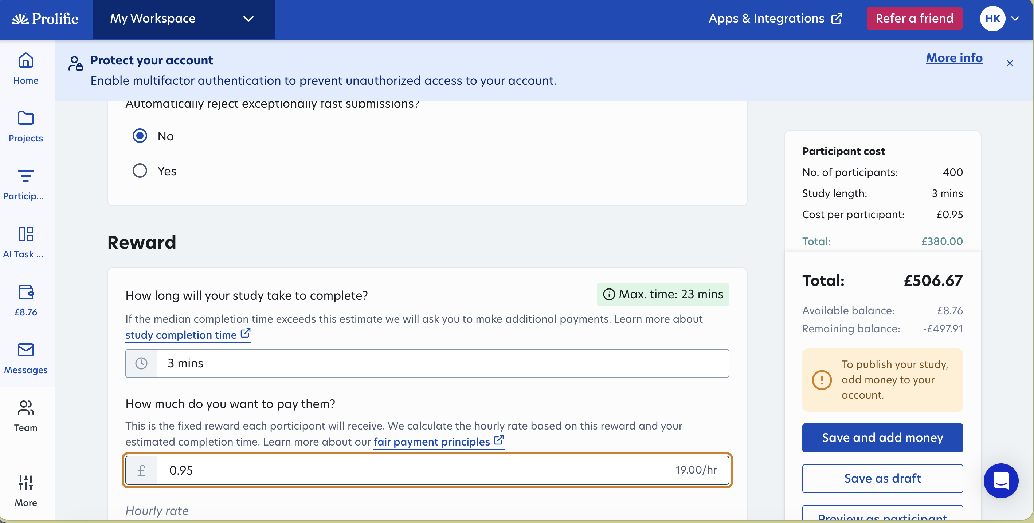

4. Ethical Considerations (if required)
Ethical Approval Status: Pending – To be submitted for review
Have you obtained ethical approval? (Yes/No) No

5. Declaration and Signatures
Principal Investigator’s Declaration:
I hereby declare that the information provided in this proposal is accurate and complete to the best of my knowledge.
Signature: 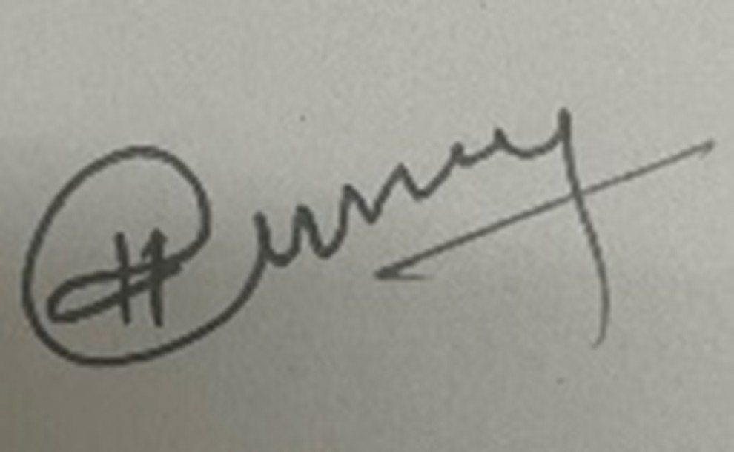

Date:007/04/2026

For Official Use Only
Approval remarks:
Amount sanctioned: ____________________

Principal, Great Lakes Institute of Management, Gurgaon

[To be filled in later once the paper / project report is published]
Paper published Date:
Publication Title:
Publication Journal:
Journal Category:
DOI:

